About us

Vision
Our vision is to grow as a quality solutions provider with a difference focusing on reliability, trust & customer delight

Mission
It is our endeavor to carefully understand our clients’ operations, processes & people to execute precise solutions

We will go extra mile to serve our clients & support them in their path to success.

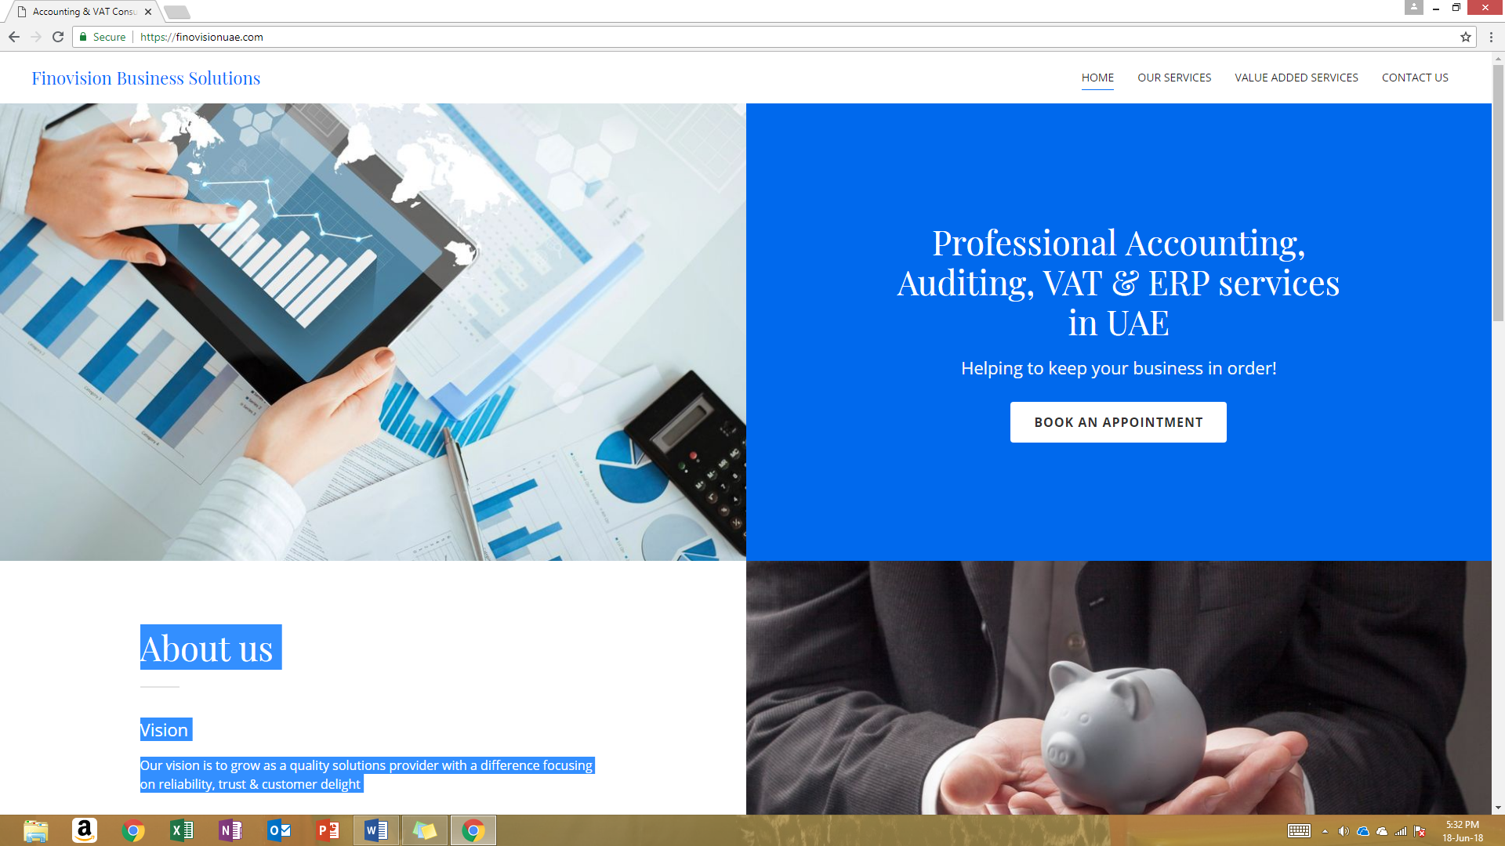

Consultancy Services



Accounting & bookkeeping
We understand that every business is unique. Keeping this in mind, we conduct a detailed study our clients' business operations & roll out perfect accounting solutions.

We strengthen your accounting & back office team with setting up accounts , carrying out routine accounting, bookkeeping & payroll functions as well as finalization of accounts at specific time periods.

Auditing & Internal controls
It is vital for contemporary businesses to effectively manage business risks & information risks. Control over financials, effective & efficient operations and compliance with regulations are other critical challenges.

We support our clients to effectively deal with these challenges & achieve business objectives by offering quality & reliable auditing & assurance services at affordable value.

We perform analytical & substantive procedures to test the design & operation of internal controls, examine business transactions & documents and provide comprehensive reports to the business owners to enable decision making.

Tax Consultancy
We meticulously study our clients business transactions and guide them to align with tax laws & regulations.

We assist our clients to maintain proper documents & records and submit tax returns to ensure full compliance with the regulations and prevent administrative penalties.

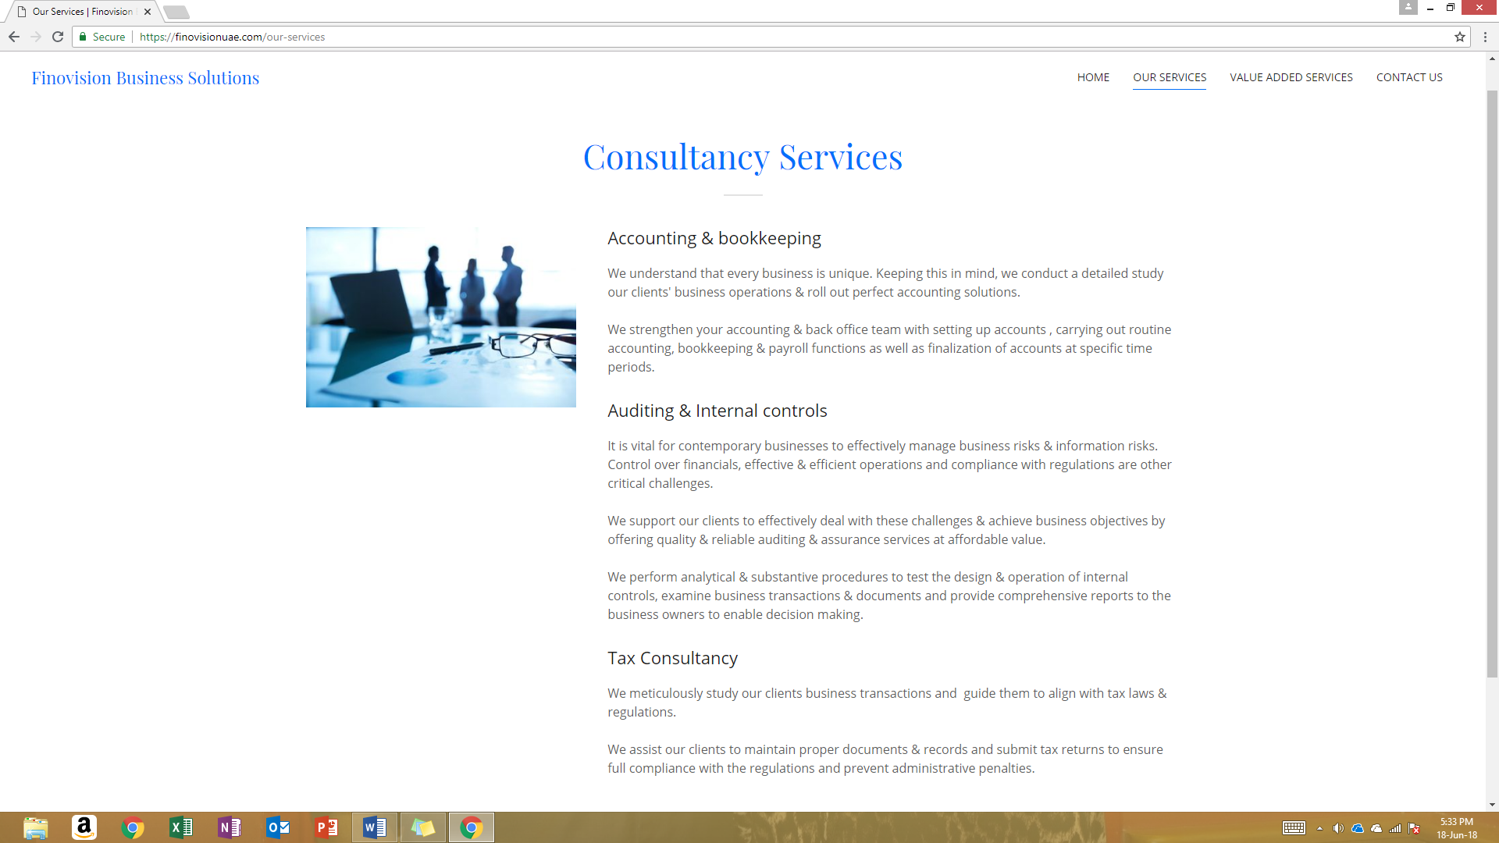

Value Added Services

ERP / Accounting Software

We have partnered with reputed software developers & distributors to offer value added solutions to our clients.

With our strong domain experience in accounting, we offer our clients ERP application most suitable for their business needs.

POS/Restaurant /Hospitality Solutions

With our strong collaboration with strategic partners, we roll out specialized applications for hotels, restaurants, cafes, bakeries, super markets & groceries to manage their business operations with one application.

CRM/Work Flow Management

As digital transformation is the buzz word in the business world, we offer our clients cutting edge CRM applications to manage their client accounts.

We offer tailor made applications most suitable for client's unique business needs and configure the modules to derive maximum value from their investment.

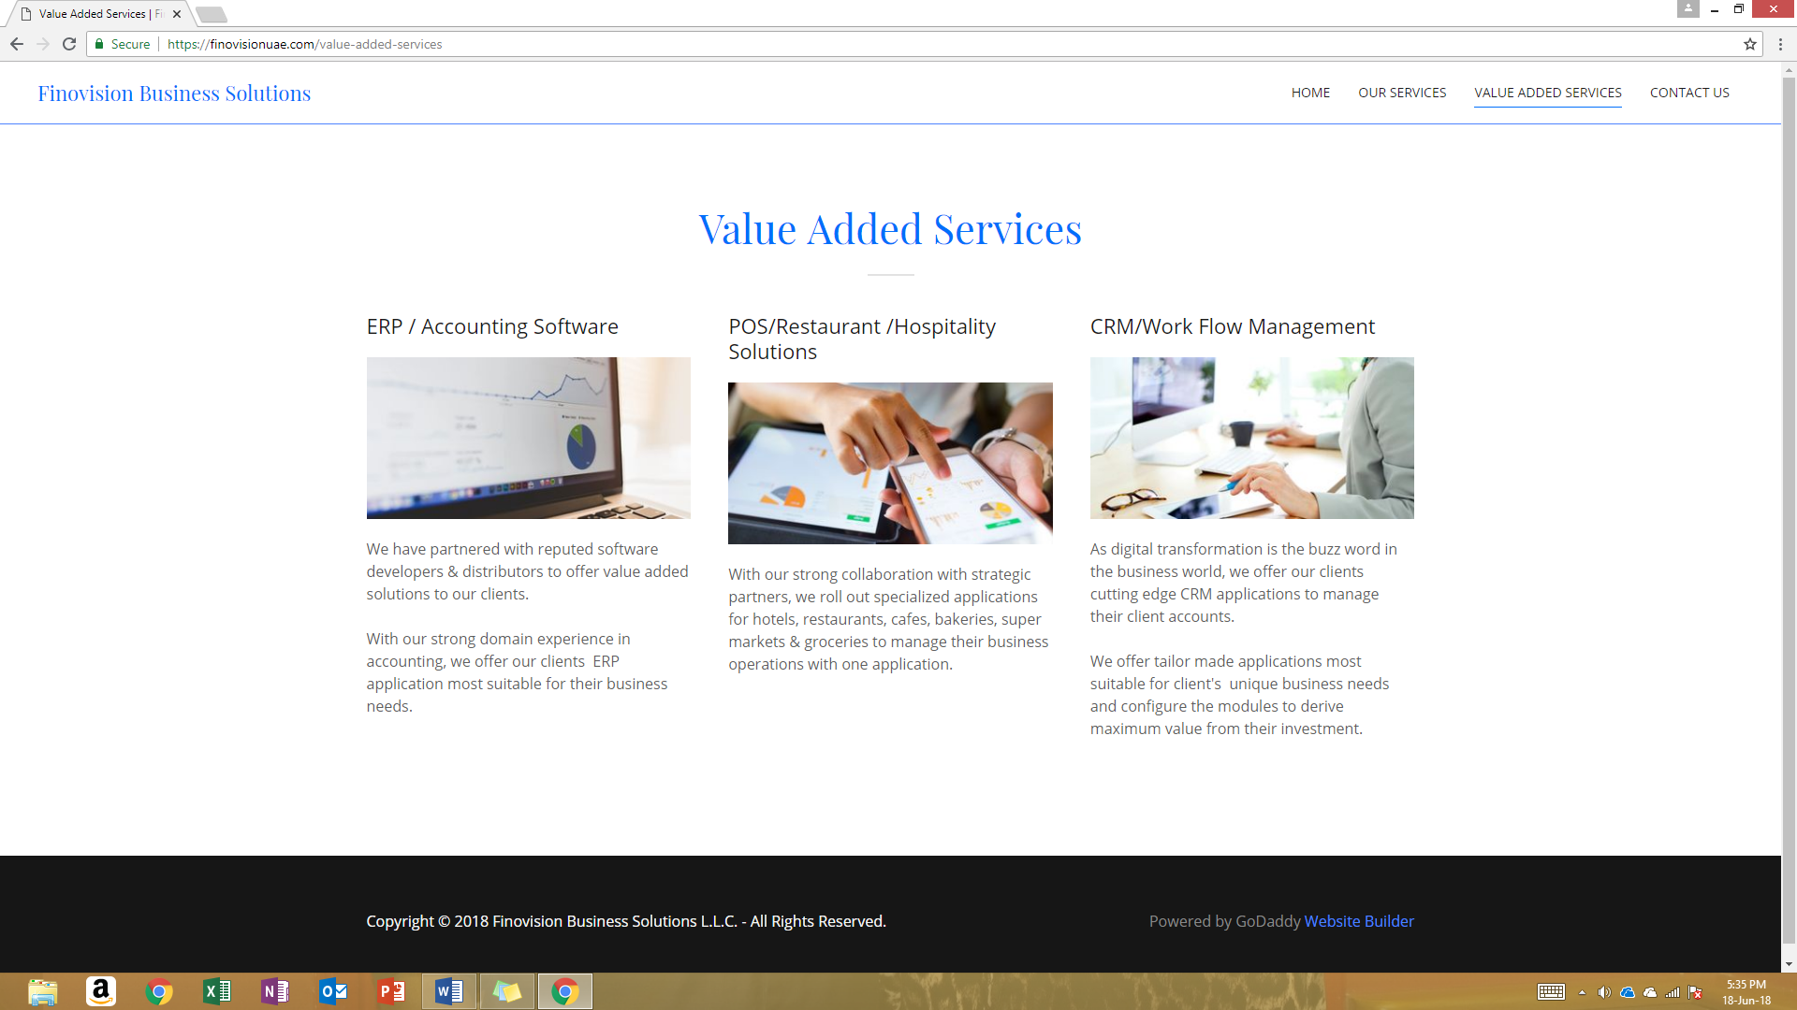

Get in Touch

Name
Email*

SEND

Finovision Business Solutions LLC
Sharjah, United Arab Emirates
Mobile: 050 301 0675

Hours
Sunday - Thursday: 9am - 6pm
Saturday: By appointment
Friday: Closed

